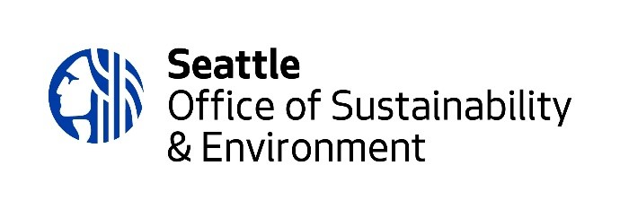
Environmental Justice Fund

2024 Application Form

Rolling deadline until $250,000 total funding is fully awarded or until 5PM on October 20, whichever comes sooner.

Please review the 2024 EJ Fund Guidelines, which provide useful information about the application process. ​Refer to page 7 for the Review Team’s criteria for evaluating proposals.

Group or organization name
Project name
Grant request size (select one) | $10,000  $25,000
Project start date

(Must be at least 60 days after the application has been submitted. Example: For a proposal submitted on September 4, the project start date should be no sooner than November 3.)

APPLICATION CHECKLIST
Before starting this application form, please complete the EJ Fund eligibility quiz. You can find the quiz when you begin your online application.
Complete this application form, including the project timeline and project budget
Upload the completed application form in the online application.
If your project involves changes to a space or takes place on property that is not owned by your group or organization, please upload a letter of authorization from the land or property owner via the online application.

NARRATIVE QUESTIONS

Response length: We encourage brief responses, keeping in mind the capacity of the community reviewers. Being clear is more important than the length of your answer. Please aim to submit no more than 4 pages of narrative responses in 12-point font, not including the project timeline and project budget. You may click here for a sample application that is complete and concisely worded.

1. COMMUNITY NEED: Who is the community you are serving? How are they being impacted by climate change and/or environmental hazards?

2. PROJECT: What will you do, and how will you do it? How many people will be served?

3. PEOPLE: Who is involved with the design and implementation of the project? What lived experiences/skills do they bring? You may include any partners and their roles in this project, if applicable.

4. IMPACT: What are your project outcomes? How do these address the community impacts you named in “Community Need” (Q1)?

5. RACIAL JUSTICE: What practices and approaches does your organization or group use to advance racial justice?

PROJECT TIMELINE

Use the table below to show us a brief timeline for your project. Add lines, if needed. (Activities must begin at least 60 days after the application submission date and must be completed no later than December 19, 2025.)

Activity | Date/Timeline

PROJECT BUDGET

PLEASE COMPLETE BOTH THE INCOME AND EXPENSE SECTIONS, INCLUDING LINE-ITEM DETAILS.
Add lines, if needed.

INCOME  * List all sources of funding for your project.  * Add lines, as needed. | AMOUNT | STATUS  * Tell us if the income is committed, pending or to be submitted.
Environmental Justice Fund request
In-Kind Donations (please list below)
TOTAL PROJECT REVENUE

EXPENSES  * List all expenses planned for the EJ Fund portion of your project. The total should match the EJ Fund request amount.  * Do not list expenses covered by other funding sources.  * Add line items, as needed. | AMOUNT | LINE-ITEM DETAILS  * Share details about the expenses listed. This column must be completed.
Salaries and benefits

Program Supplies

Stipends

Consultants/Subcontractors

Insurance

Fiscal sponsor fee, if applicable

Other project expenses (list each additional item separately)

TOTAL PROJECT EXPENSES

